# Image result for srm logo downloadSRM Institute of Science and Technology- Ramapuram campus

Department of Mathematics

18MAB204T- Probability and Queuing Theory

Year/Sem: II/IV

Branch: CSE, IT

UNIT 2

PART-B

1.



1. n =100, p = 1/5, q = 4 /5
2. n =100, p = 1/4, q = 4 /5
3. n =25, p = 1/5, q = 4 /5
4. n =100, p = 3/5, q = 2/5

Answer: a

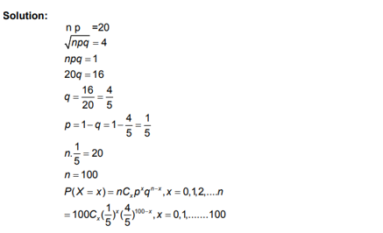

2.



1. $P\left(X=x\right)={nc}_{x}p^{x}q^{n-x} ,x=0,1,2,… , n$., mean= npq, variance=np
2. $P\left(X=x\right)={nc}_{x}p^{n-x}q^{n} ,x=0,1,2,… , n$., mean= np, variance=npq
3. $P\left(X=x\right)={nc}_{x}p^{x}q^{n-x} ,x=0,1,2,… , n$., mean= np, variance=npq
4. $P\left(X=x\right)={nc}_{x}p^{x}q^{nx} ,x=0,1,2,… , n$., mean= np, variance=npq

Answer: b

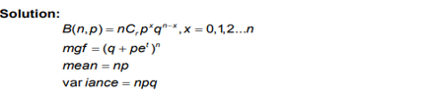

3. find the M.G.F of poisson distribution

(a) $e^{-t(e^{t}-1)}$ (b) $e^{-λ(e^{t}-t)}$ (c) $e^{-t(e^{t}-2)}$ (d) $e^{-λ(e^{t}-1)}$

Answer: d

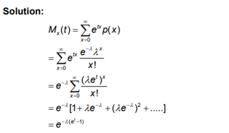

4.

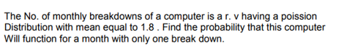

1. 0.397 (b) 0.297 (c) 0.279 (d) 0.197

Answer: b

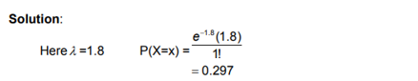

5.



1. λ = -1 (b) λ = 2 (c) λ = 3 (d) λ =1

Answer: d

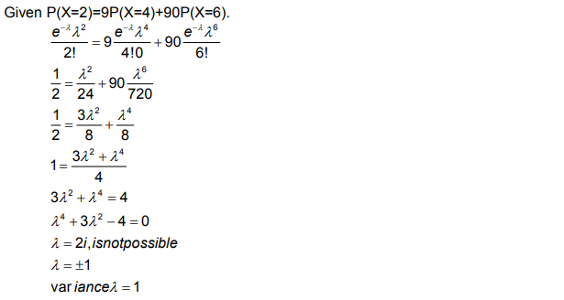

6.



$P\left(X=x\right)=q^{x-1}p , x=1,2,3,……,M.g.f=\frac{q}{1-{qe}^{t}} mean=\frac{q}{p } , variance=\frac{q}{p^{2}}$

$PP\left(X=x\right)=q^{n-x}p , x=1,2,3,……,M.g.f=\frac{p}{1-{qe}^{t}} mean=\frac{q}{p } , variance=\frac{q}{p^{2}}$

$P\left(X=x\right)=q^{x-1}p , x=1,2,3,……, M.g.f=\frac{p}{1-{qe}^{t}} mean=\frac{p}{q } , variance=\frac{q}{p^{2}}$

$P\left(X=x\right)=q^{n-x}p , x=1,2,3,.. n , M.g.f=\frac{p}{1-{qe}^{t}} mean=\frac{q}{p } , variance=\frac{q}{p^{2}}$

Answer: c

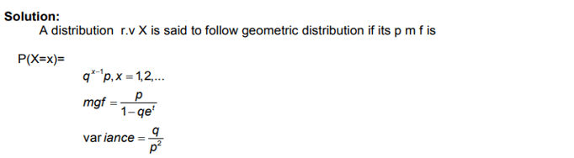

7.If the probability that a target is destroyed on any one shot is 0.5. What is the probability that it would be destroyed on the 6thattempt?

1. 0.5160
2. 0.1560
3. 0.0156
4. 0.2156

Answer: c

Solution

Given p=0.5 and q=1-p=1-0.5=0.5

We know that $P(X=x)=q^{x-1}p$

$P(6th attempt)=P(X=6)={\left(0.5\right)}^{5}(0.5)$ =0.0156

8.



1. $\frac{3}{4}$ (b) $\frac{1}{2}$ (c) $\frac{4}{3}$ (d) $\frac{1}{4}$

Answer: c

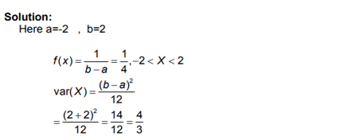

9.

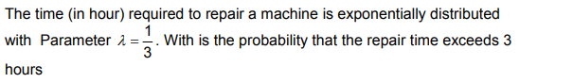

1. $\frac{1}{3}$ (b) $\frac{1}{e}$ (c) $e$ (d) $e^{\frac{-1}{3}}$

Answer: b

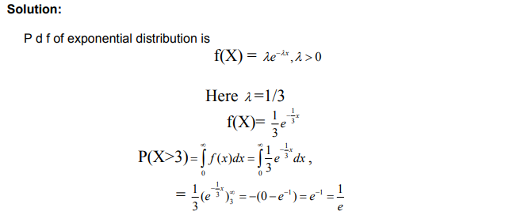

10.

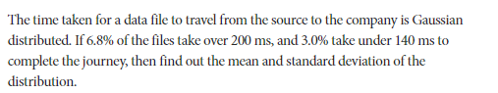

$μ=173.5 ,σ=17.8$

$μ=17.8 ,σ=117.8$

$μ=17.5 ,σ=71.8$

$μ=73.5 ,σ=17.8$

Answer : a

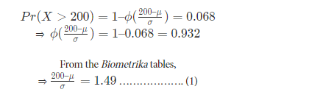

11. State and prove the memoryless property of Geometric distribution.

Solution:

If X is a random variable with geometric distribution, then X lacks memory

P( X> (s+t) / X>s) = P (X>t).

L.H.S: P( X> (s+t) / X>s) =  = 

P(X=x) =  , x = 1,2,3,4…

Now P(X>k) = P( X=k+1) + P(X=k+2 )+ P(X=k+3)+P(X=k+4),…..

= …

= (1+q++++…..)

=  =  =  = >P(X >k) = 

Therefore P( X> (s+t) / X>s) =  = = P(X>t)

Hence the Geometric distribution lacks memory.

12.A quality control inspector rejects 40% of a certain product. Find the probability that the first acceptable product is the third one inspected.

Solution:

Probability of rejection (q) = 0.4

Probability of acceptance (p) =0.6

P.m.f of the geometric distribution is P(X=x) = qx-1p , x = 1,2,3,4,….

P (first acceptable is the third one inspected) = q3-1p = (0.6) (0.4)2 = 0.096.

13.The daily consumption of milk in a city in excesses of 20000 litres is approximately exponentially distributed. The average excesses in consumption of milk is 3000 litres.. The city has a daily stock of 35000 litres of milk. What is the probability that, of two days selected at random, the stock is insufficient for both the days?

Solution :

Let X denotes the consumption of milk in the city then

Y = X – 20000 then Y follows the exponential distribution = 1/3000



f(Y)= $\frac{1}{3000}e^{- \frac{y}{3000}}$

P( X>35000) = P(X-20000>35000-20000) = P(Y>15000) = = e-5

(memory less property (X>a) = e-aλ)

14.Out of 800 families with 4 children each, how many families would be expected to have (i) 2 boys and 2 girls (ii) at least 1 boy (iii) at most 2 girls and (iv) children of both genders. Assume equal probabilities for boys and girls.

Solution:Considering each child is a trial, n = 4.

Assuming that birth of a boy is a success, Then X ~ B (n, p)

P[X=x] = nCxpxqn-x, x = 0, 1, 2, …..n.

By data, p = ½ and q= ½.

1. P[2 boys and 2 girls] = P[X = 2] = 4C2 =

∴ No. of families having 2 boys and 2 girls = 800x $\frac{3}{8}$ = 300

1. P[ at least 1 boy] = P[X≥1] = 1- P[X<1] = 1- P[X=0]

= 1- 4C0 = 1- =

∴ No. of families having at least 1 boy = 800x $\frac{15}{16}$ = 750.

1. P[ at most 2 girls] = P[exactly 0 girl, 1 girl (or) 2 girls]

= P[X=4, X=3, X=2]

= 1- {P[X=0] + P[X=1]}

=1- {4C0+ 4C1}

= 1-[] = 1- =

∴ No. of families having at most 2 girls = 800x $\frac{11}{16}$ = 550

1. P[ children of both genders] = 1 – P[children of the same gender]

= 1 – {P (all are boys) + P (all are girls)}

= 1 – {P(X=4) + P (X=0)}

= 1 – {4C4+ 4C0}

= 1 - 2 = 1 - =

∴ No. of families having children of both gender = 800x = 700

15. Find the MGF, mean and variance of Exponential distribution

Proof:

MGF: Mx(t)=E(etx)=

=

= θ

=θ

Mx(t)=

16. The probability of a man hitting a target is 1/3. How many times must he fire so that the probability of hitting at least once is more than 90%?

Solution :

Let X be the number of times he hits the target.P=1/3 => q=2/3. Then X follows a Binomial distribution, with P(X=x) = given >0.9 To find n

* 1-P(X<1) > 0.9
* - P(X<1) > - 0.1 => P(X<1) < 0.1 => P(X=0) < 0.1
* < 0.1 =>
* n log(2/3) < log(0.1)
* n > 5.65
* 
* Therefore he must fire at least 6 times.

17.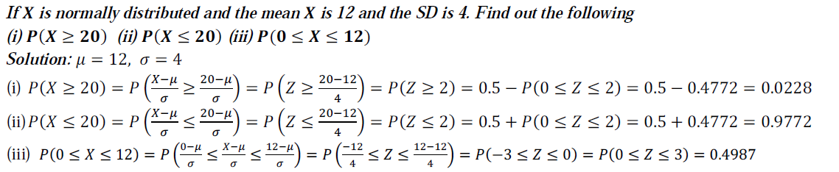18.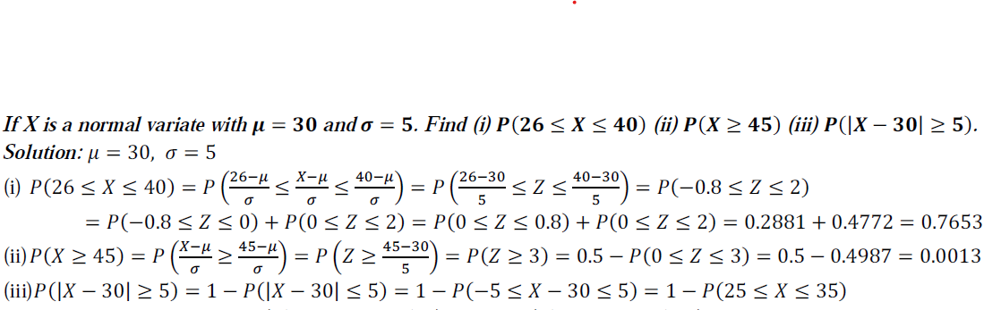

19.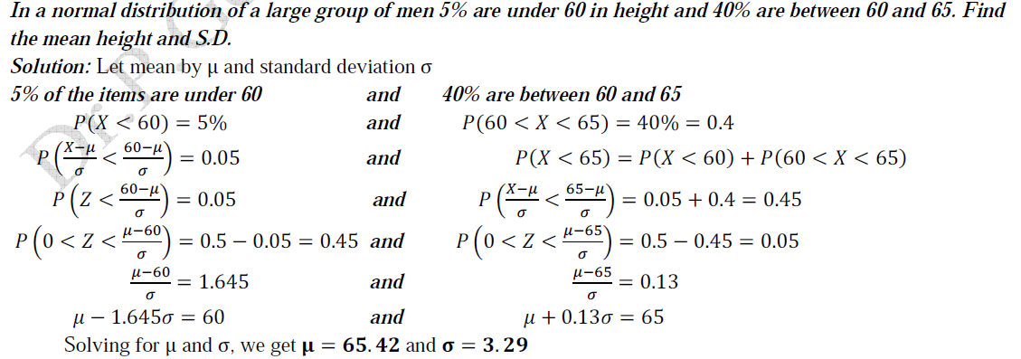

20.

